27.AIM*:-* ***To draw UML diagrams for supermarket managment system.***

***USE CASE DIAGRAM:***

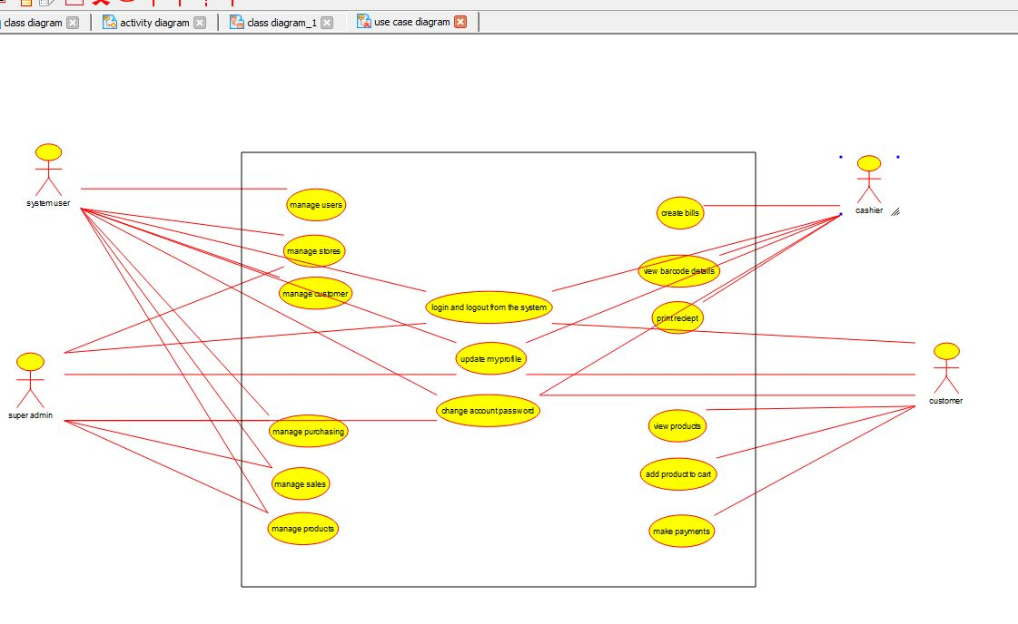

***ACTIVITY DIAGRAM:***

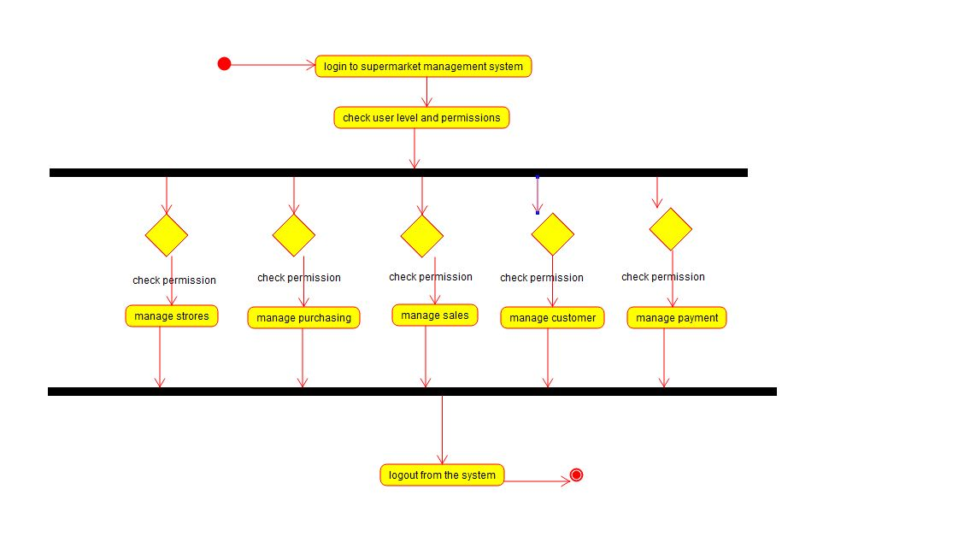

***CLASS DIAGRAM:***

